**PYTHON ROUGH RECORD**

SUBMITTED TO : Sreelekha Miss

SUBMITTED BY : Ihsan.K

**Experiment: 1 Date:** 18/01/2022

**PALINDROME**

**AIM**

Write a python program to reverse a string and check the given string is palindrome or not.

**ALGORITHM**

Step1 : Start

Step2 : Take the input from the user and store it to str1

Step3 : find the reverse as str1[::-1] and store it to str2

Step4 : if (str2==str1) then print ‘It is palindrome’ else ‘It is not

palindrome’

Step5 : stop

**PROGRAM**

str1 = input("Enter a string:")

str2 = str1[::-1]

print("Reverse of the string is:", str2)

if(str2==str1):

print("It is palindrome")

else:

print("It is not a palindrome")

**OUTPUT**

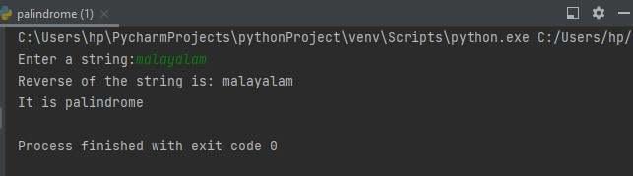

**Experiment: 2 Date:** 18/01/2022

**LIST**

**AIM**

Insert n elements to a list using python

1. Find the third highest element from the list
2. Find the length of the list
3. Sort the list

**ALGORITHM**

Step1 : start

Step2 : create list

Step3 : read the number of elements and store it to num

Step4 : add items to the list using for loop

Step4 : print the list

Step5 : print length of the list as len(list)

Step6 : sort the list as list.sort()

Step7 : print sorted list and third largest number

Step8 : stop

**PROGRAM**  
  
**list=[]  
num=int(input("Enter the number of elements:"))  
for i in range(num):  
 data=int(input("Enter elements:"))  
 list.append(data)  
 print("List before sorting is:",list)  
print("The length of the list is:",len(list))  
list.sort()  
print("list after sorting is:",list)  
print("third largest number is:",list[2]**

**OUTPUT**

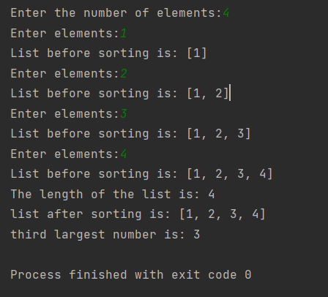

**Experiment: 3 Date:** 18/01/2022

**MULTIPLY LIST**

**AIM**

Write a python function to multiply all numbers in a list.

**ALGORITHM**

Step1 : start

Step2 : create function ,set result =1

Step3 : multiply each element ‘x’ with ‘result’, result=result*x, return

result using for loop

Step4 : create list ‘A’, read the size of the list ‘n1’

Step5 : print the elements of the first list and append the items,

A. append(k) using for loop

Step6 : print function multiplylist(A)

Step7 : stop

**PROGRAM**

**def** multiplylist(list):  
 result = 1  
 **for** x **in** list:  
 result = result * x  
 **return** result  
  
A = list()  
n1 = int(input(**"Enter the size of first List : "**))  
print(**"Enter the element of the first list"**)  
**for** i **in** range(int(n1)):  
 k = int(input(**""**))  
 A.append(k)  
print(**"Multiply of all numbers in first list : "**,multiplylist(A))

**OUTPUT**

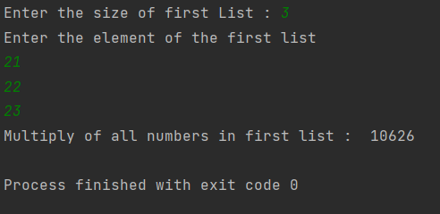

**Experiment: 4 Date:**19/01/2022

**FILE OPERATION**

**AIM**

Write a python program to append text to a file and display the text. Count the number of lines in the appended text file.

**ALGORITHM**

Step1 : start

Step2 : create text file

Step3 : write hello into it

Step4 : count=0

Step5 : read file

Step6 : for every line in the file, count+=1

Step7 : print ‘number of lines in the file’, count

Step8 : stop

**PROGRAM**

**file = open('sample.txt', 'a')  
file.write('hello')  
count = 0  
file = open('sample.txt','r')  
for line in file:  
 count += 1  
print("Number of lines in the file:", count)  
file.close()**

**OUTPUT**

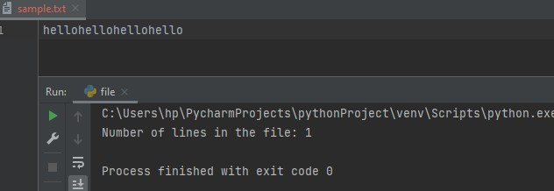

**Experiment: 5 Date:** 25/01/2022

**FACTORIAL**

**AIM**

Accept a number using textbox and print its factorial on clicking the button using python script.

**ALGORITHM**

Step1 : start

Step2 : import tkinter

Step3 : Enter number in the text box

Step4 : if(n==1 or n==0)

Step5 : return 1

Step6 : else n*factorial(n-1)

Step7 : Print the factorial number in textbox

Step8 : stop

**PROGRAM**

**import tkinter as tk  
def factorial(n):  
 return 1 if (n == 1 or n == 8) else n * factorial(n-1);  
def calculate():  
 result = factorial(int(entryText.get()))  
 info.config(text=result)  
  
mw = tk.Tk()  
mw.title('FACTORIAL !!')  
mw.geometry("200x200")  
mw.resizable(0, 0)  
  
L1 = tk.Label(text="enter the number:", width=15)  
L1.grid(row=1, column=1)  
  
entryText = tk.Entry(text=1, bg='white', fg='black')  
entryText.place(x=50, y=25, width=100, height=25)  
  
btn = tk.Button(text='calculate', command=calculate)  
btn.place(x=50, y=75, width=100, height=25)  
  
info = tk.Label(text='result', bg='white', fg='black')  
info.place(x=50, y=125, width=100, height=25)  
  
mw.mainloop()**

**OUTPUT**

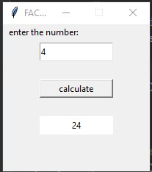

**Experiment: 6 Date:** 27/01/2022

**FIBONACCI SEQUENCE**

**AIM**

Create two textboxes and accept the upper limit and lower limit. List the Fibonacci numbers between these values on clicking the button.

**ALGORITHM**

Step1 : start

Step2 : import tkinter

Step3 : Enter the upper limit and lower limit in the textboxes

Step4 : if upper_value < lower_value

Step5 : print please enter a valid limit

Step6 : else First_value,Second_value = 0,1

Step7 : Print Fibonacci sequence

Step8 : fib=[0,1],Next= 0

Step9 : while Next < upper_value

Step10: Next = First_value+Second_value, fib.append(Next)

Step11: if Next in range(lower_value,upper_value)

Step12: in_limit.append(Next)

Step13: To update values, First_value = Second_value, Second_value=Next

Step14: Print the Fibonacci sequence in the textbox

**PROGRAM**

**import tkinter as tk  
from itertools import tee  
  
  
def fibonacci_in_limit(l,u):  
 in_lmit=[]  
 fib=[]  
 lower=l  
 upper=u  
 #First two terms  
 lower_value,upper_value = lower,upper  
 if upper_value<lower_value:  
 print("Please enter valid limit:")  
 else:  
 First_value,second_value =0,1  
 print("fibonacci Sequence:")  
 fib =[0,1]  
 Next=0  
 while Next < upper_value:  
 Next = First_value+second_value  
 fib.append(Next)  
 if Next in range (lower_value,upper_value):  
 in_lmit.append(Next)  
 #update values  
 First_value=second_value  
 second_value = Next  
 lbl_fib.config(text=fib)  
 lbl_fib.config(text=in_lmit)  
def fibonacci():  
 lower = int(entryLower.get())  
 upper = int(entryUpper.get())  
 fibonacci_in_limit(lower,upper)  
  
mw = tk.Tk()  
mw.title("Fibonacci in limit")  
mw.geometry("600x600")  
mw.resizable(1,1)  
  
  
lbl_1=tk.Label(text="lower:",relief = tk.FLAT)  
lbl_1.place(x=0,y=0,width=150,height=25)  
  
entryLower=tk.Entry(bg="white",fg="black")  
entryLower.place(x=50,y=25,width=100,height=25)  
  
lbl_1=tk.Label(text="upper:",relief=tk.FLAT)  
lbl_1.place(x=125,y=0,width=150,height=25)  
  
entryUpper=tk.Entry(bg="white",fg="black")  
entryUpper.place(x=175,y=25,width=100,height=25)  
  
btn=tk.Button(text="Calculate",command=fibonacci)  
btn.place(x=50,y=75,width=150,height=25)  
  
lbl_3=tk.Label(text="fib:",relief=tk.FLAT)  
lbl_3.place(x=0,y=150,width=150,height=25)  
  
lbl_fib=tk.Label(text="",relief=tk.FLAT,bg="white")  
lbl_fib.place(x=100,y=150,width=250,height=25)  
  
lbl_fib_lm=tk.Label(text="",relief=tk.FLAT)  
lbl_fib_lm.place(x=150,y=275,width=250,height=25)  
  
mw.mainloop()**

**OUTPUT**

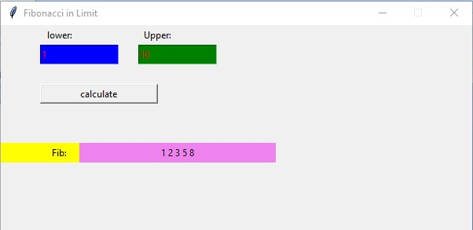

**Experiment: 7 Date:**03/02/2022

**COUNT**

**AIM**

Create a text area . Enter some text into it. Print the number of words in the text on clicking the button.

**ALGORITHM**

Step1: Start

Step2: import tkinter

Step3: Create a textbox and add lines into it

Step4: phrase = T.get('1.0',END),words = phrase.split()

Step5: print words

Step6: wordcount = len(words),find the length of the words and store it to wordcount

Step7: print wordcount as the total word count

Step8: Stop

**PROGRAM**

**from tkinter import *  
import tkinter as tk  
from tkinter import Tk  
def count():  
 phrase = T.get('1.0',END)  
 words = phrase.split()  
 print(words)  
 wordcount = len(words)  
 print("The total word count is:", wordcount)  
root = Tk()  
  
root.geometry("300x200")  
  
T=Text(root, height=5, width = 52)  
l=Label(root,text="Fact of the day")  
l.config(font=("Courier",14))  
Fact = """python has a simple syntax similar to the english language\n"""  
b1=Button(root,text="count",command=count)  
l1=Label(root, height=10,width=60)  
  
l.pack()  
T.pack()  
b1.pack()  
  
T.insert(tk.END,Fact)  
tk.mainloop()**

**OUTPUT**

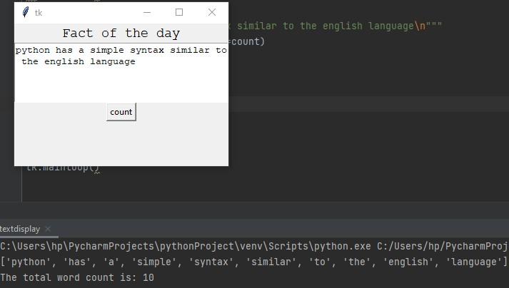

**Experiment: 8 Date:**

**LOGINAPP**

**AIM**

Create a database with a table having fields username and Password

* Insert values to the table
* Create a login page with two text boxes and a button.
* Redirect to a home page on successful login

**PROCEDURE**

Open Terminal and change to Desktop then create a django project

1. django-admin startproject log
2. cd log
3. python3 manage.py startapp logapp
4. python3 manage.py makemigrations
5. python3 manage.py migrate
6. python3 manage.py runserver

To create admin

1. python3 manage.py createsuperuser

**PROGRAM**

* log

**settings.py**

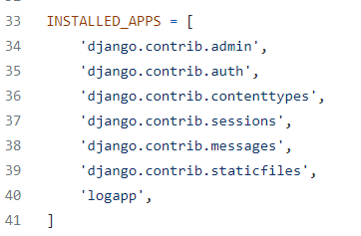

**urls.py**

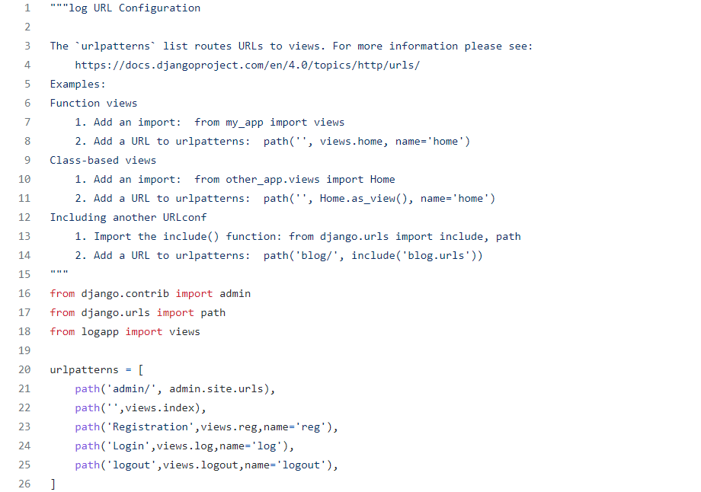

* logapp

**index.html**

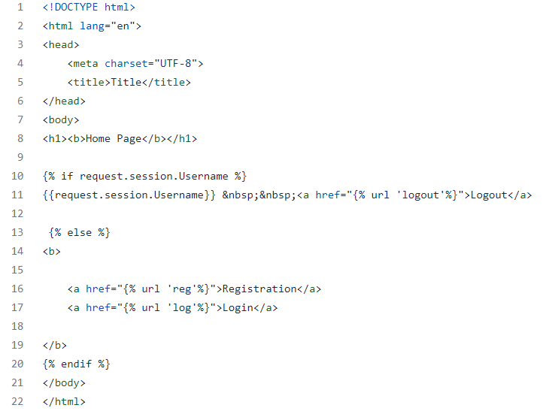

**login.html**

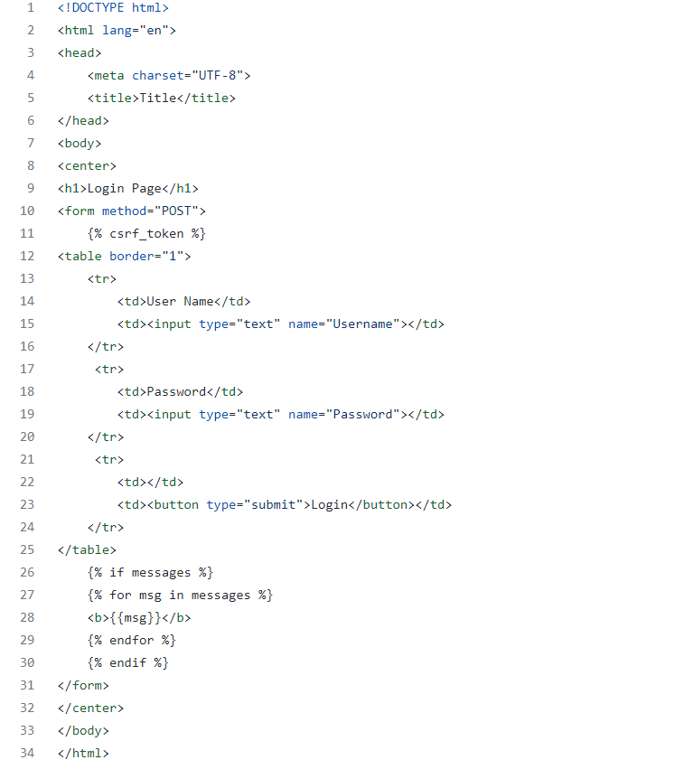

**registration.html**

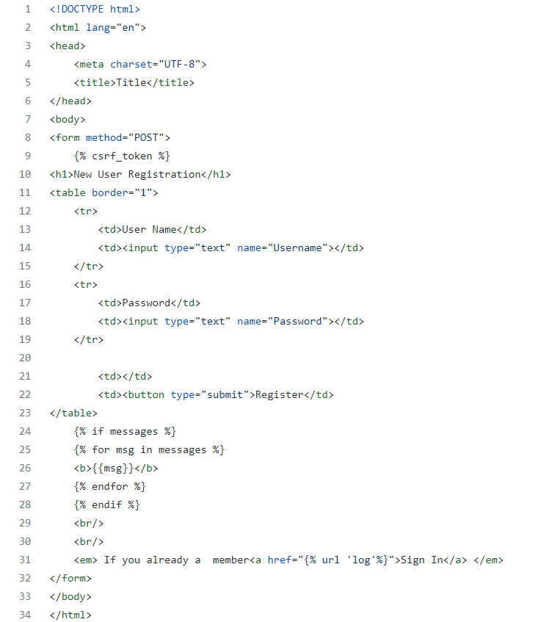

**admin.py**

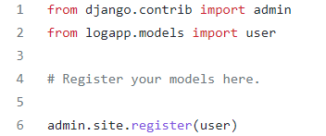

**models.py**

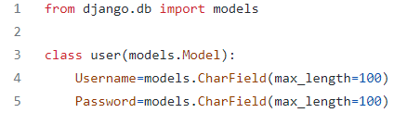

**views.py**

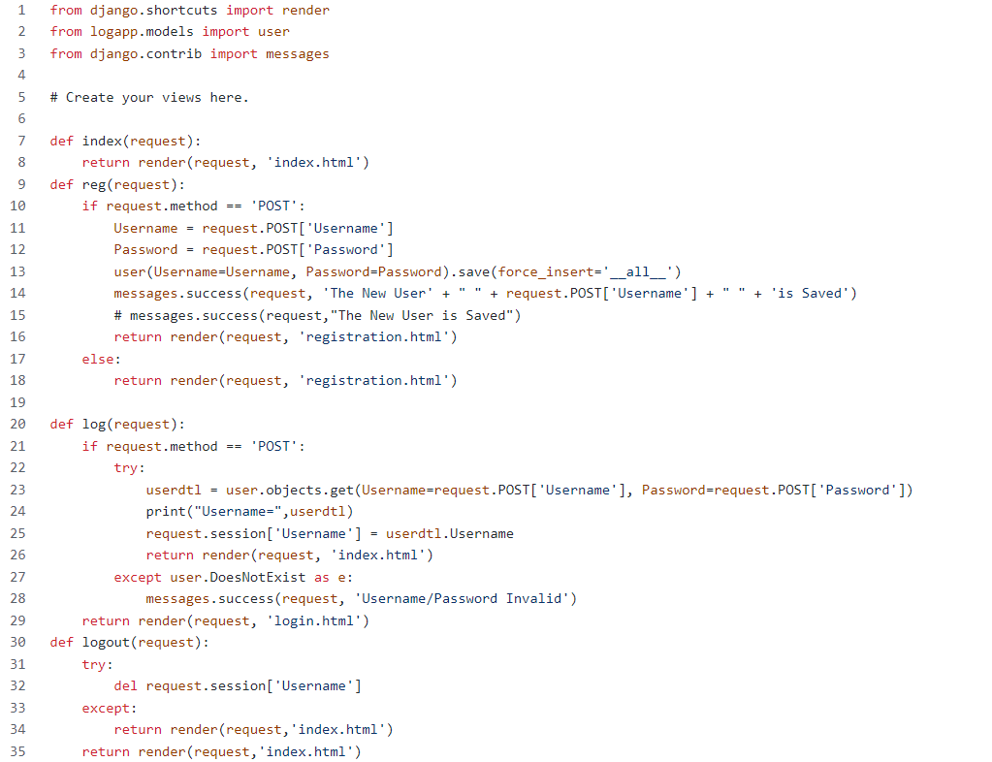

**OUTPUT**

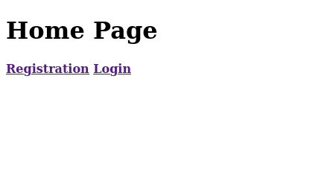

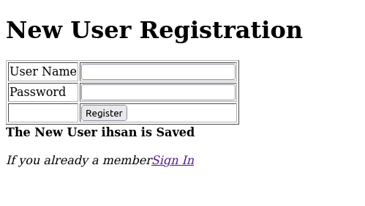

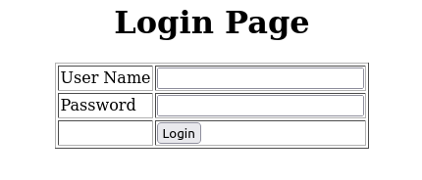

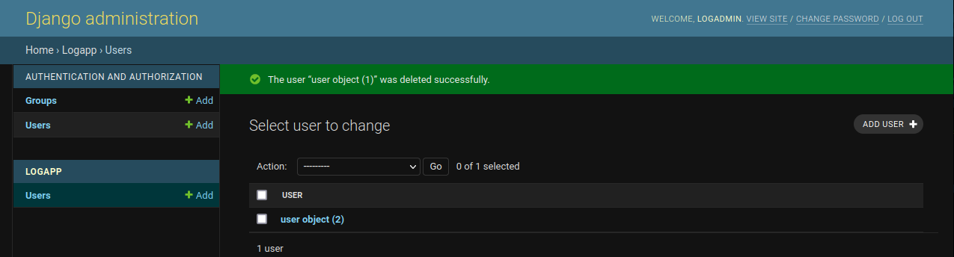

**Experiment: 9 Date:**

**BOOKAPP**

**AIM**

Using python and SQL, develop a program to accept book information viz. acc_no,title and author from a web page and store the information in a database. Search for a book with title specified by the user and display the search results with proper headings.

**PROGRAM**

* shop

**settings.py**

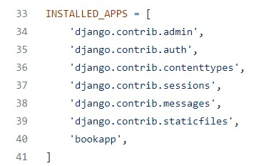

**urls.py**

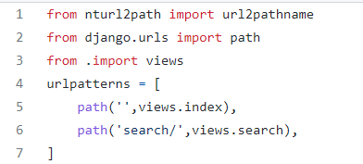

* bookapp

**index.html**

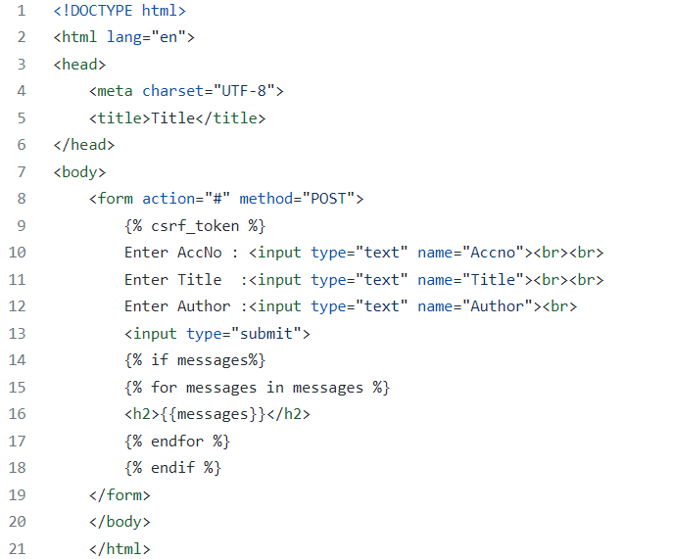

**search.html**

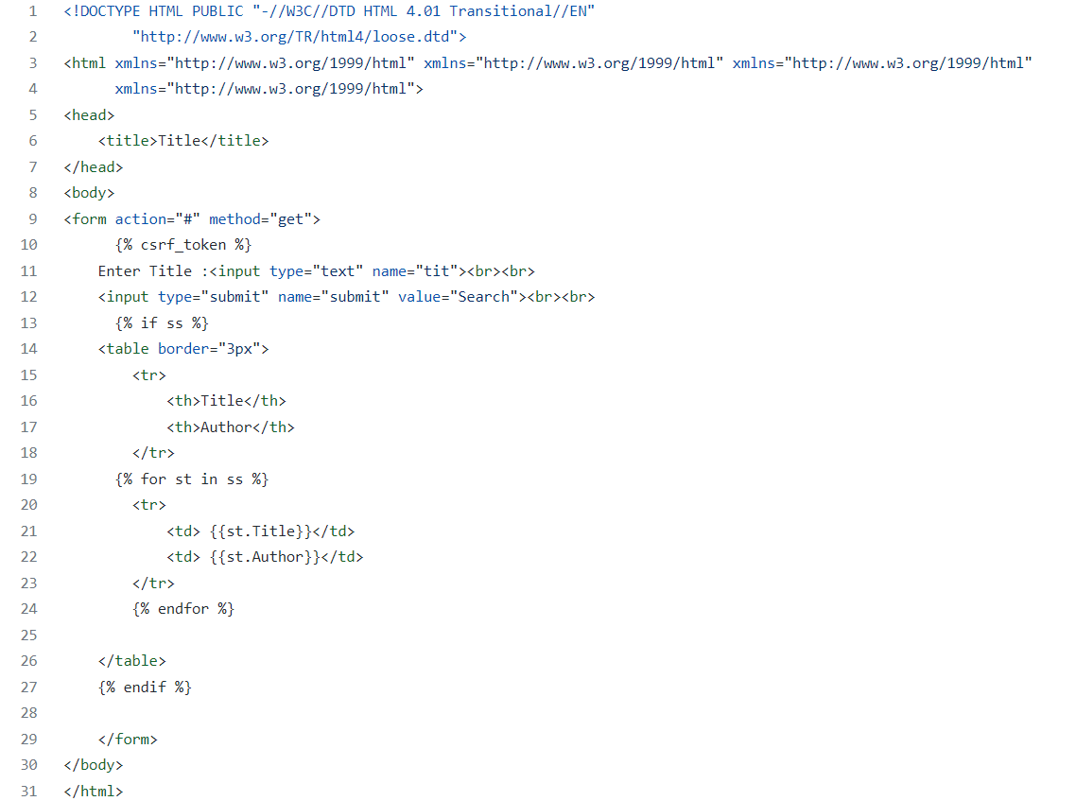

**admin.py**

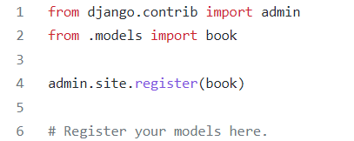

**models.py**

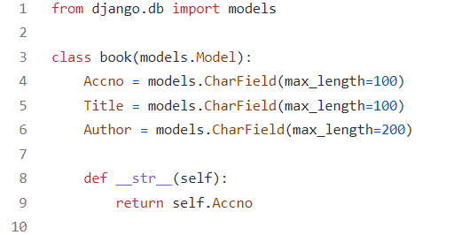

**urls.py**



**views.py**

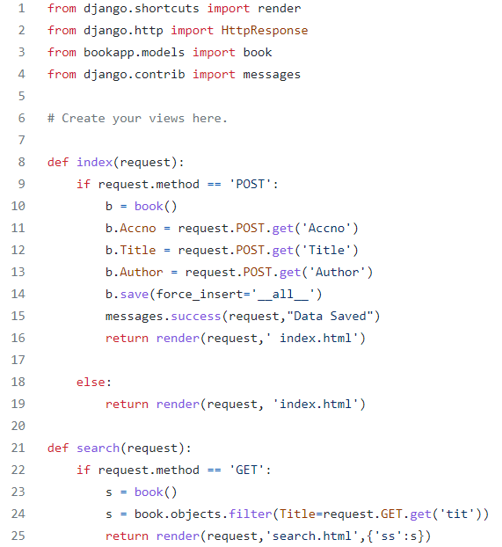

**OUTPUT**

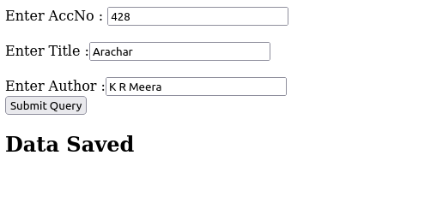

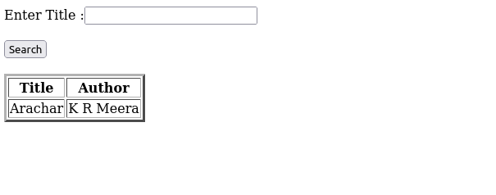

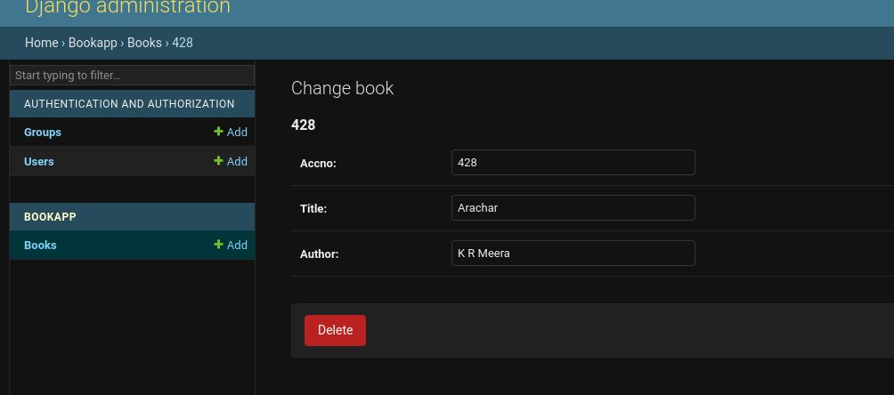

**Experiment: 11 Date:**

**CRUDAPP**

**AIM**

More database exercises using python

**PROGRAM**

* crud

**settings.py**

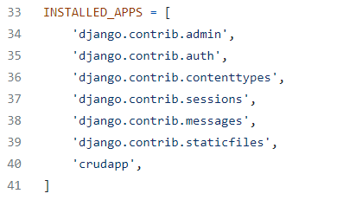

**urls.py**

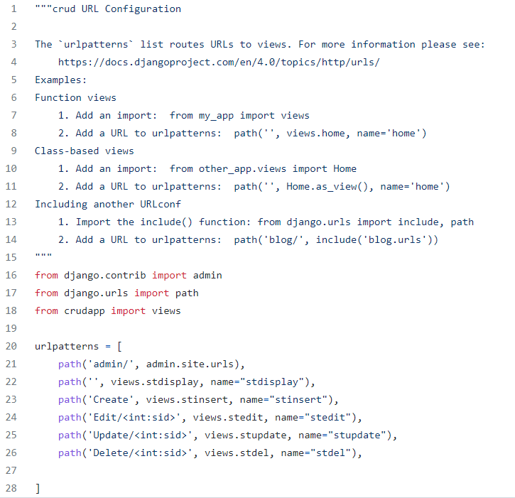

* crudapp

**create.html**

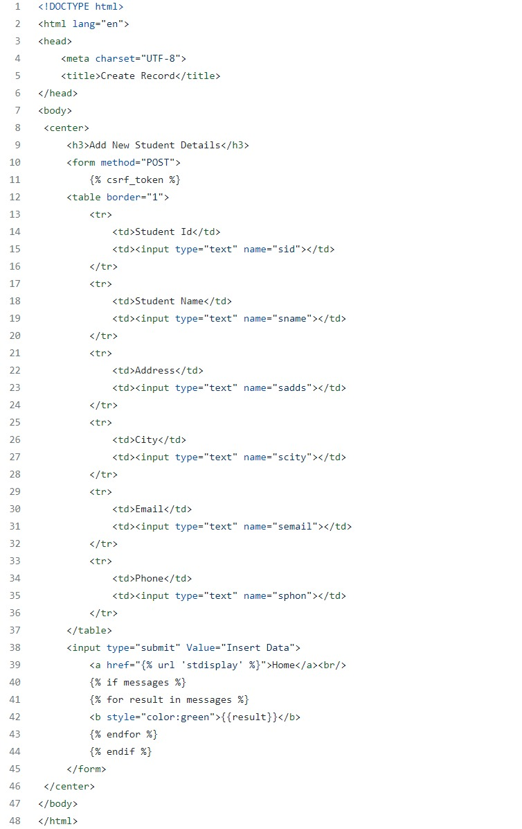

**edit.html**

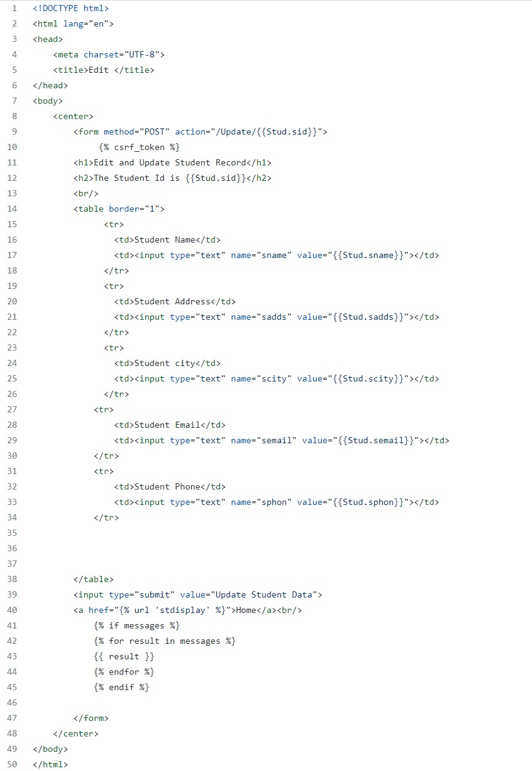

**index.html**

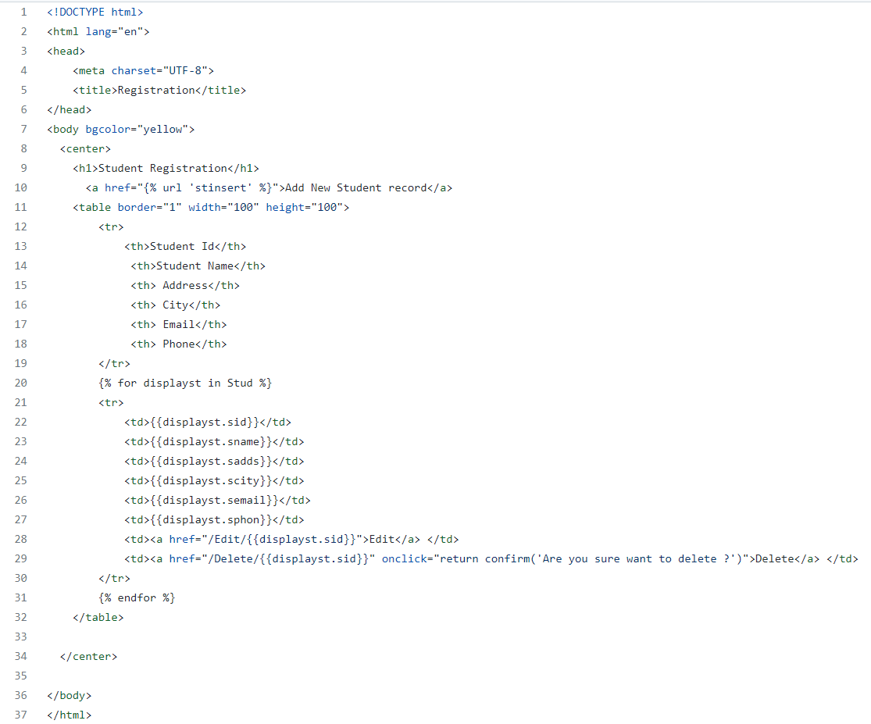

**admin.py**

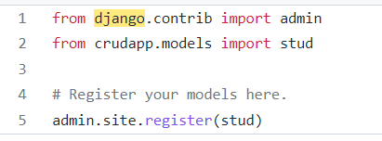

**forms.py**

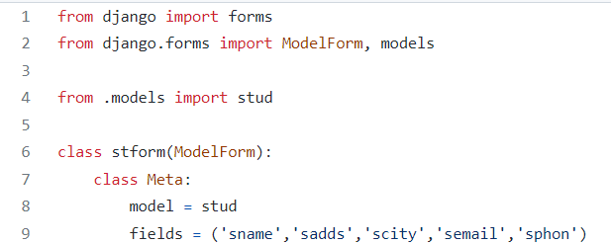

**models.py**

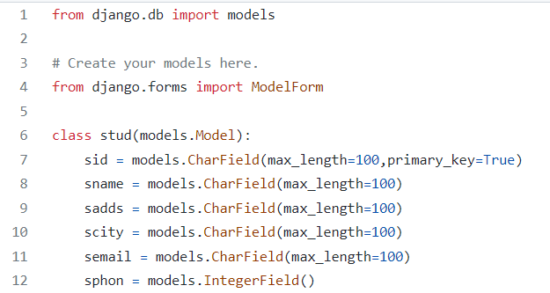

**views.py**

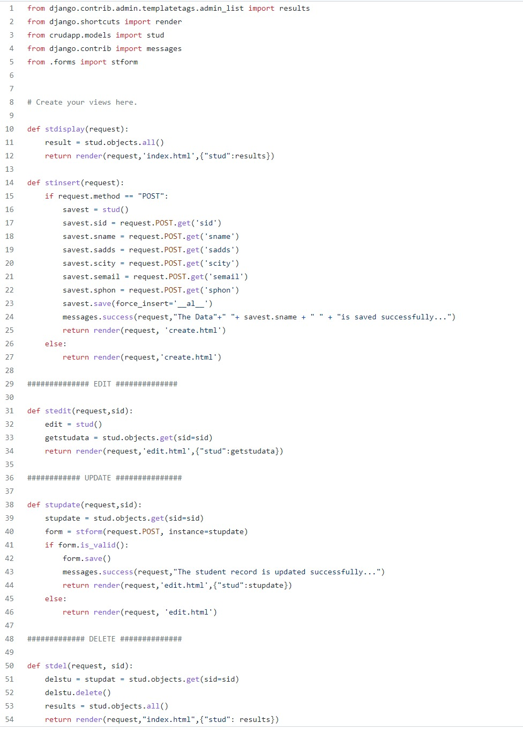

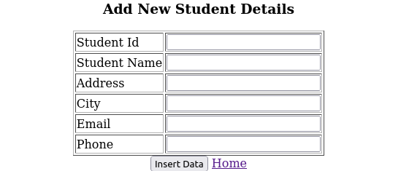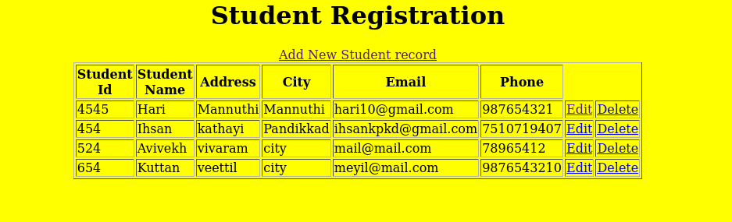**OUTPUT**

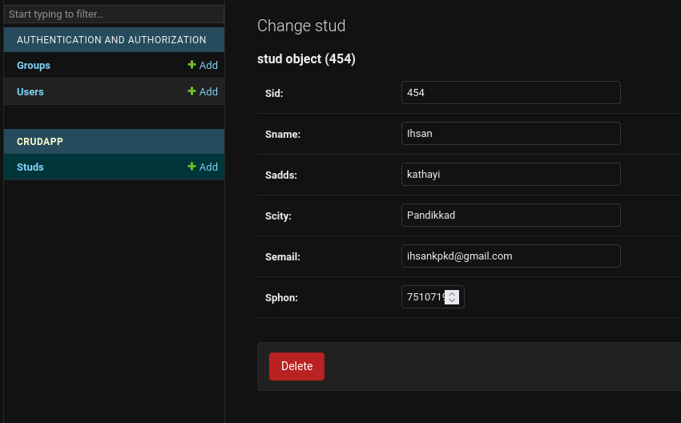

**Experiment: 12 Date:**

**SERVER AND CLIENT**

**AIM**

Network exercises using python

**PROGRAM**

**Server.py**

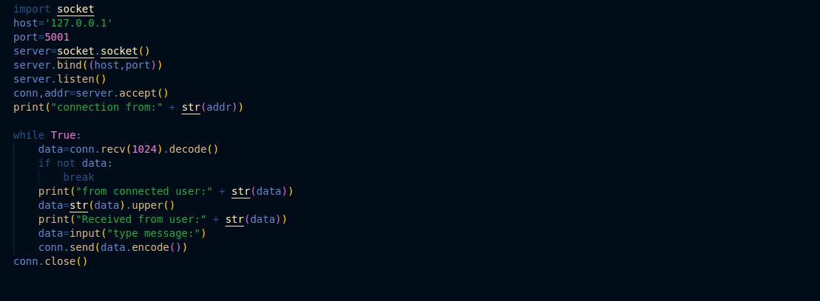

**Client.py**

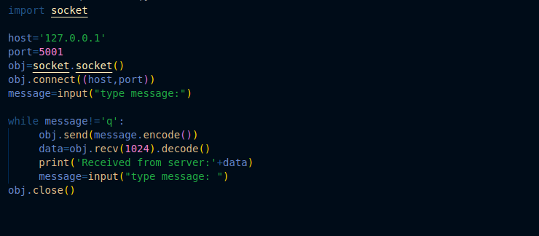

**OUTPUT**

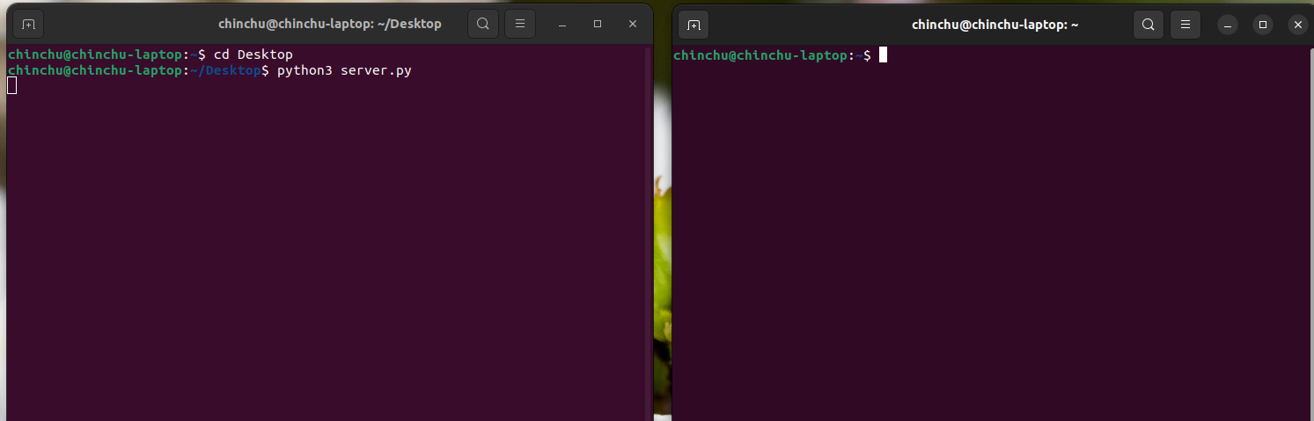

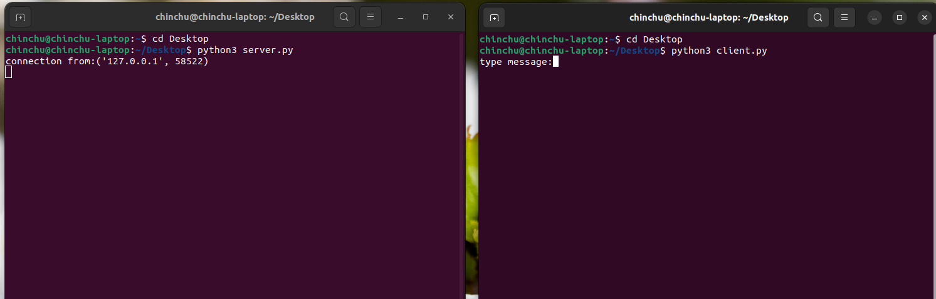

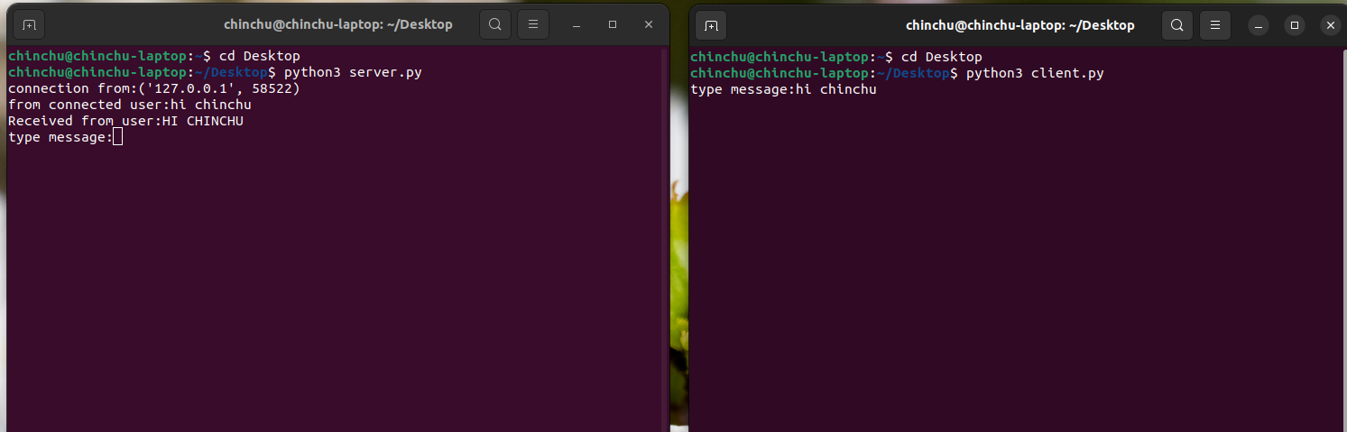

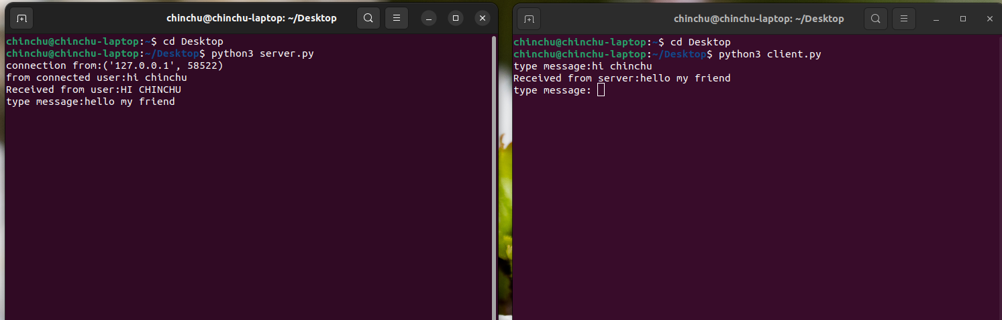

**Experiment: 12 Date:**

**STUDENT MARK UPLOAD**

**AIM**

Network exercises using python

**PROGRAM**

* student

**settings.py**

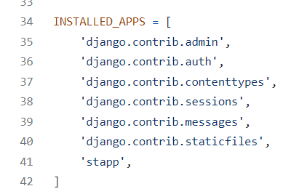

**urls.py**

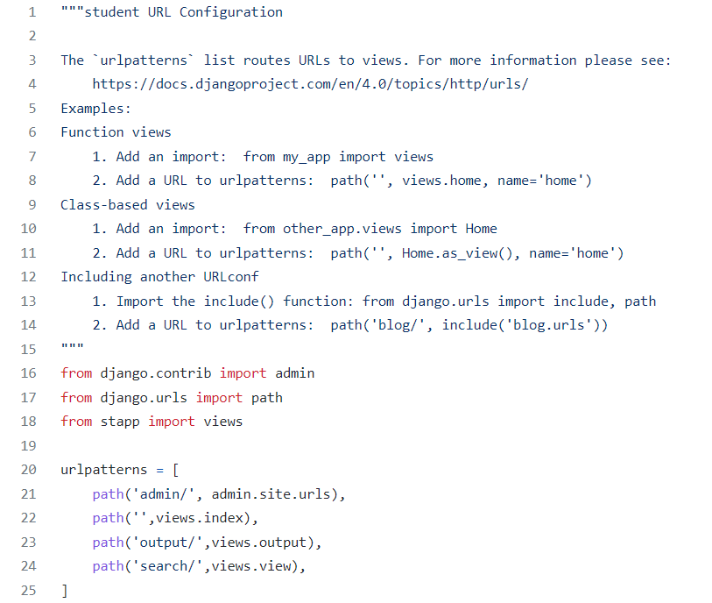

**Index.html**

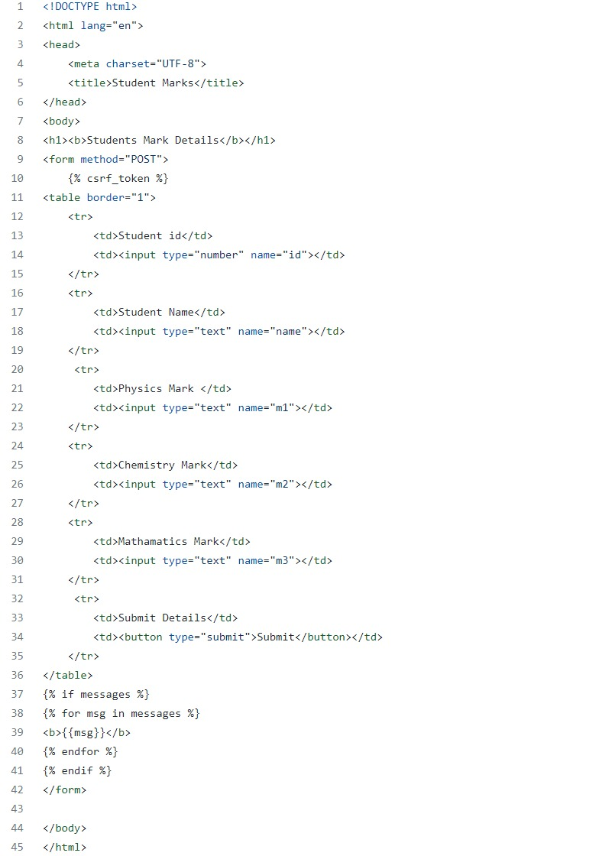

**output.html**

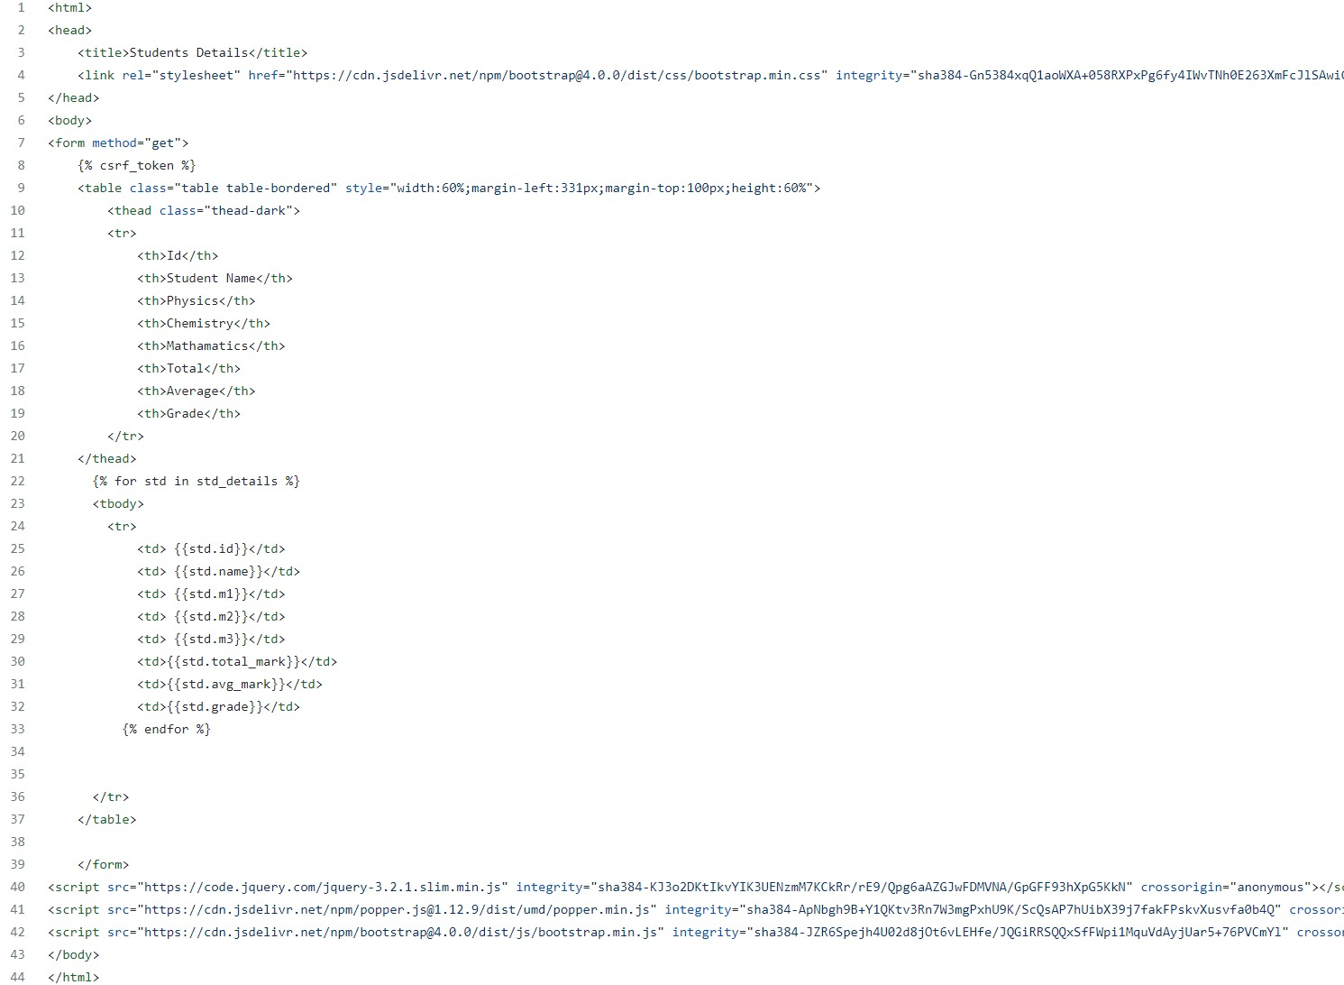

**serach.html**

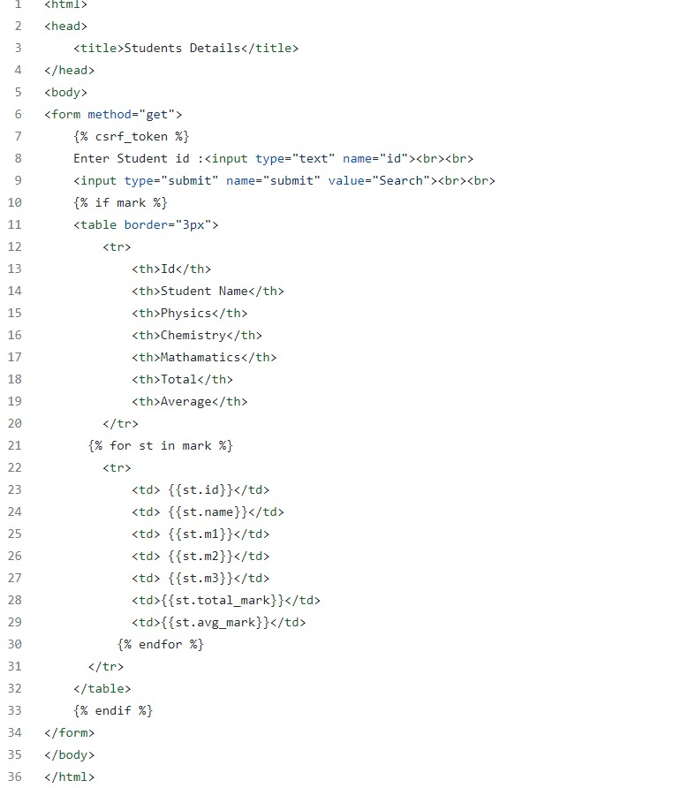

**admin.py**

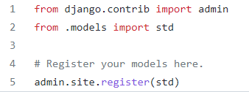

**models.py**

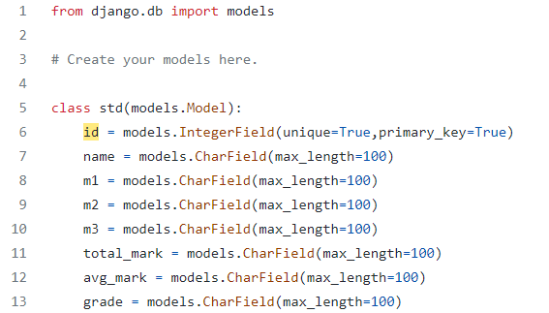

**Views.py**

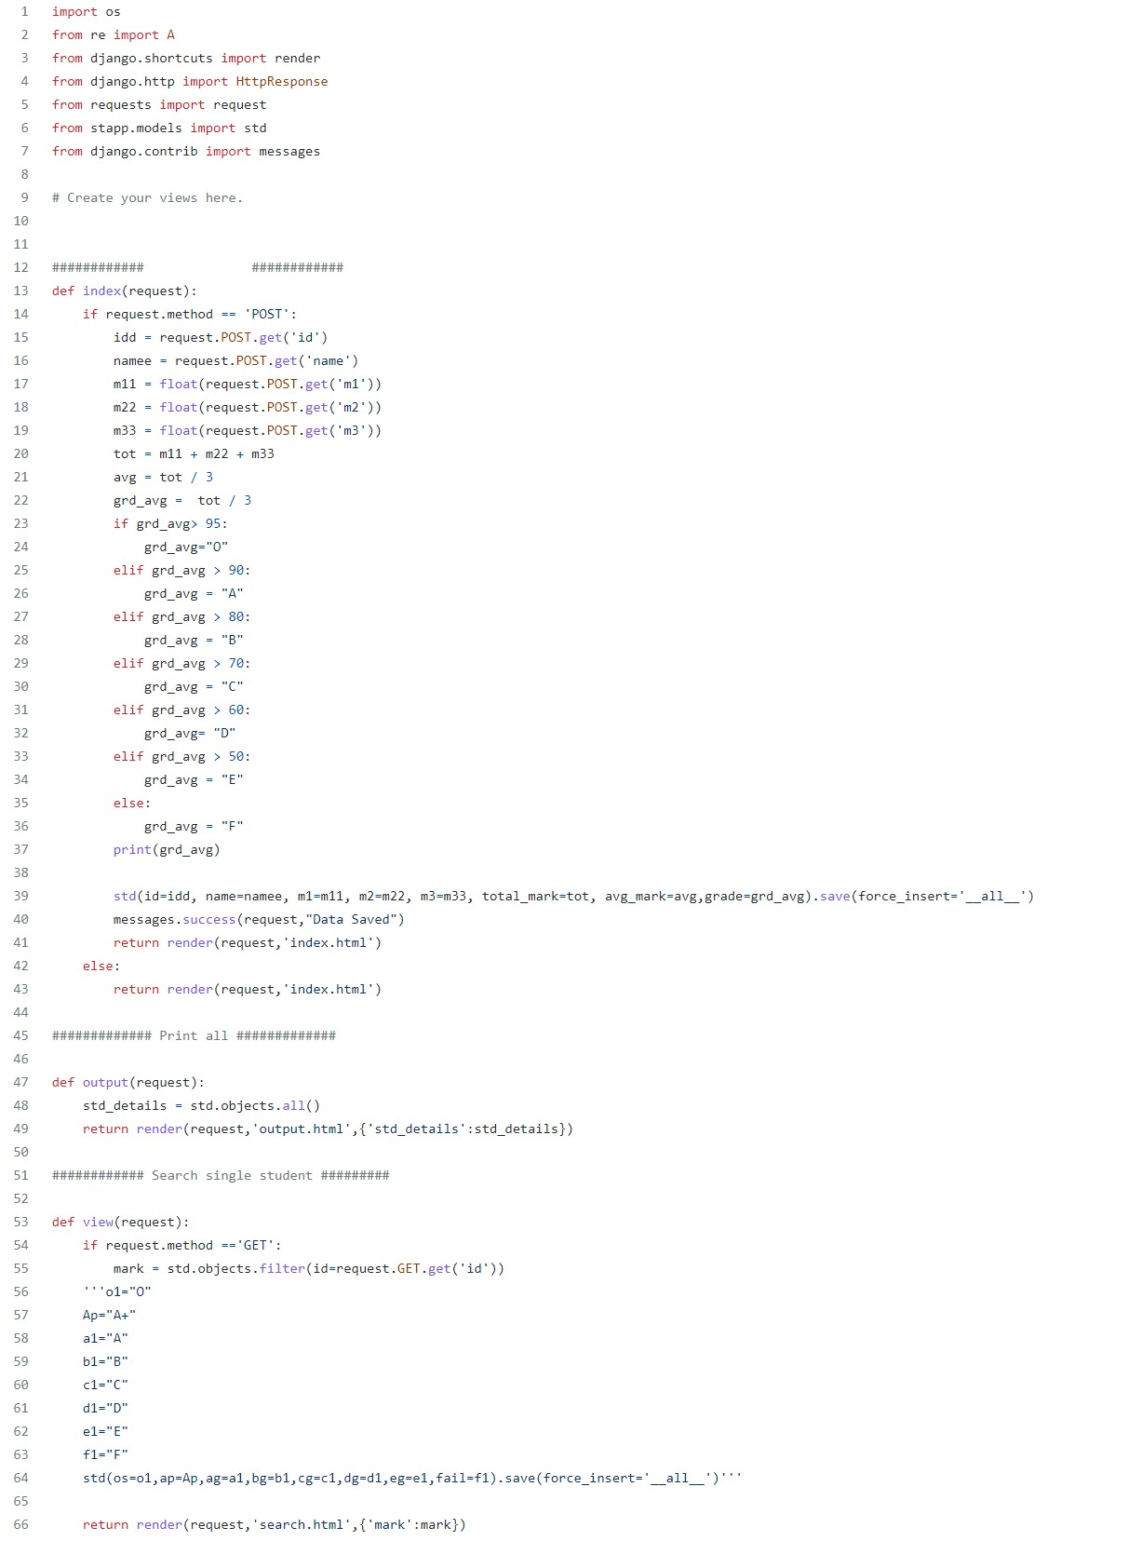

**OUTPUT**

